Scientific cultivation of Tulsi for higher income
Author:- Shailesh Kumar, Sweta Mishra and A K Singh
Email shailesh_agri@yahoo.com
Inroduction
Tulsi or holy basil (Ocimum sanctum LINN, belongs to family Lamiaceae), an annual plant, 30-60cm height, leaf, stem and branches usually purplish, Flowers in racemes. Distributed all over the India. Leaf or whole plant are used for commercial purpose. Leaf is mainly used for oil extraction and ayurvedic preparations. It is good source of vitamin A, Vitamin C, Calcium, Zinc, Iron, Chlorophyll and it posses anti bacterial, insecticidal properties, its leaves have capabilities to purify contaminated water. Scientific studies present evidences for its anti-inflammatory, antioxidant, analgesic (pain-reducer), antipyretic (fever-reducer), hepatoprotective (liver-protector) cancer-fighter, diabetes-preventer, blood vessel-protector, destresser, immune-booster etc properties. Has approx 60 species identified and categorized under Ocimum genus in plant family lamiaceae. It is also called as queen of herbs. The present market price of leaves is Rs 800-900/kg and the price of seed is Rs 200/kg. Farmer can earn 2.5 t 3.0 lakhs in three months after selling the fresh herb and seed of tulsi plant
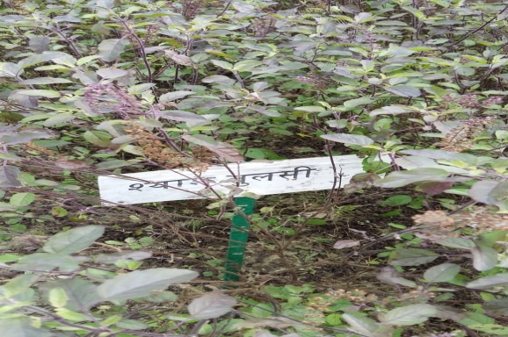
Scientific/Commercial cultivation
Soil and climatic conditions:
Can be grown on variety of soils, well-drained soil helps better vegetative grown. Water logged condition is not suitable, it can cause root-rot and stunted growth. It flourishes well under long days and high temperatures and found favorable for plant growth and oil production. Topical and sub-topical climate is suited for its cultivation.
Soil preparations: It is suggested to add 15 tonnes of farm yard manure per hectare during the preparation of land and mixed well in the soil.
Nursery raising and planting: The suitable time for nursery raising is third week of February and transplanting of seedling/plants is generally started in the middle of April. The plant is propagated by seeds. The size of raised nursery bad is 15" x 4'9" convenient. Approximately 200-300g seeds are required to raise the seedlings for one hectare of area. The seed should be sown 2cm depth in the nursery beds. The seeds germination starts in 8-12 days and the seedlings are ready for transplanting in about 6 weeks time at 4-5 leaf stage. The seedlings are transplanted at 40 x 40cm and 40 x 50cm to get high herbage and oil yield per hectare.
Time of weeding and hoeing: First weeding is done one month after planting and the second 4 weeks after the first. One hoeing after two months of planting is sufficient.
Manures and pesticide: The use of bio-pesticide (Neem (kernel, seeds & leaves), Chitrakmool, Dhatura, Cow's urine etc singly or in mixture are suggested) and bio-fertilizers (FYM, Compost, Green Manure etc.) are suggested for cultivation medicinal plants. We should avoid without chemical fertilizers and pesticides.
Irrigation: Irrigation frequency depends upon the moisture level of soil. No irrigation is required during rainy seasons. In summer 3 irrigation per month are necessary. Total 12-15 irrigations per year required depends upon type of soil.
Harvesting/post harvesting operation: Generally harvesting start at full bloom stage. The first harvest is done at 90-95 days of planting. Then it may be harvested every 65-75 days interval. Harvesting is done usually on bright sunny days for good oil yield and its quality. It is not desirable to harvest the crop if there was a rain in the previous day.
YIELD: Approximately 5 tonnes of fresh herbage can be obtained twice or thrice a year per hectare.
Address of author:
Dr. Shailesh Kumar (Assistant Professor, CBS&H, RPCAU, Pusa, Bihar-848125, India)
Dr. A K Singh (Professor, CBS&H, RPCAU, Pusa, Bihar-848125, India)
Sweta Mishra (Associate Professor, COB, SVPUA&T, Meerut-250110

